Part- 3 Chapter- 17
Aplia Homework: The Trade-Off between Inflation and Unemployment

1. The inflation-unemployment relationship
The following graph shows the combinations of unemployment and inflation that existed in the United States from 1961 through 1969.
Hint: Use the graph to answer the following questions. Select any blue point (circle symbol) on the graph to get its exact coordinates.
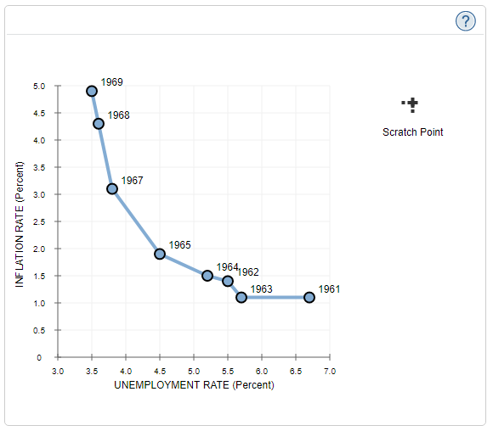
Which of the following statements about the relationship between the unemployment and inflation data for 1961–1969 is true?
There is a trade-off between unemployment and inflation.
The unemployment rate peaked at 3.5%.
A lower unemployment rate is associated with a lower inflation rate.
There is a positive relationship between unemployment and inflation.

The points on the graph represent observations along the U.S. economy's Phillips curve during the 1960s.
Use the black point (plus symbol) to help you answer the questions that follow. (Note: You will not be graded for any adjustments made to the graph.)
If the inflation rate had been 3.5% during the 1960s, the unemployment rate would most likely have been:

3.7%
4.5%
5.0%
6.5%

Based on the graph, to reduce the unemployment rate from 5.5% to 4.5%, the inflation rate should ______ by _____ percentage points.

2. The Phillips curve in the short run and long run
In the year 2025, aggregate demand and aggregate supply in the fictional country of Marjan are represented by the curves AD2025 and AS on the following graph.
Suppose potential GDP in this economy is $6 trillion.
On the following graph, use the green line (triangle symbol) to plot the long-run aggregate supply (LRAS) curve for this economy.

Economists have forecast that if the government does nothing and the economy continues to grow at the current rate, aggregate demand in 2026 will be given by the ADAADA curve, resulting in the outcome illustrated by point A. If the government pursues an expansionary policy, aggregate demand in 2026 will be given by the ADBADB curve, resulting in the outcome illustrated by point B.
The following table gives projections for the unemployment rates that would occur at point A and point B. Consider what the rate of inflation would be between 2025 and 2026, depending on whether the economy moves from the initial price level of 102 to the price level at outcome A or the price level at outcome B.
Complete the table by entering the inflation rate at each potential outcome point.
Note: Calculate the inflation rate to two decimal points of precision.
 | Unemployment Rate | Inflation Rate
A | 7% | _______
B | 5% | _______

Use the following graph to help you answer the questions that follow. (Note: You will not be graded for any adjustments made to this graph.)
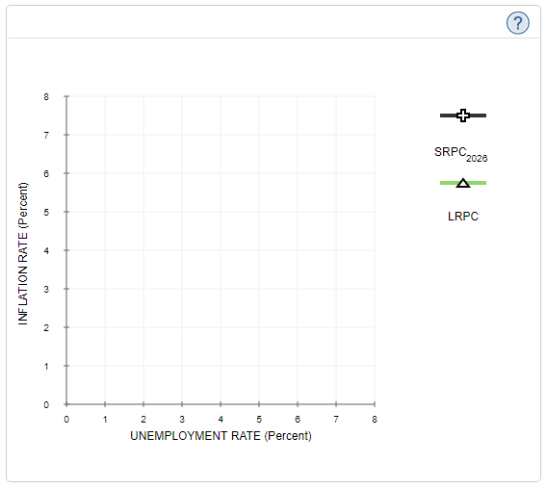

Based upon the unemployment and inflation rates you calculated previously for outcomes A and B, use the black line (plus symbol) to draw the short-run Phillips curve for this economy in 2026 ( SRPC2026 ).
The short-run Phillips curve is ___________ line:

At potential GDP
At the natural rate of unemployment
Representing the trade-off between unemployment and inflation

Now consider the long-run effects of this policy. Suppose, in particular, that following implementation of the policy, the aggregate demand curve remains at ADB. Designate the long-run equilibrium that would follow such a policy as outcome C.
Going back to the first graph, place the grey point (star symbol) at outcome C.
Because output at point C is ________ potential GDP, the unemployment rate associated with outcome C is ________ the natural rate of unemployment.

Finally, use the green line (triangle symbol) to draw the long-run Phillips curve (LRPC) on the second graph.
This line is _________ line:

At the natural rate of unemployment
Representing the trade-off between unemployment and inflation
At potential GDP

3. The derivation of the short-run and long-run Phillips curve
Suppose the price level in a hypothetical economy is currently 100, but people expect prices to be 25% higher next year. Therefore, wage contracts negotiated by workers and firms reflect the expectation that the price level will be 125 next year.
The following graph shows the aggregate demand curve (AD) and the short-run aggregate supply curve (AS25) for this economy.
Use the following graph to answer the questions that follow. (Note: You will not be graded for any adjustments made to this graph.)
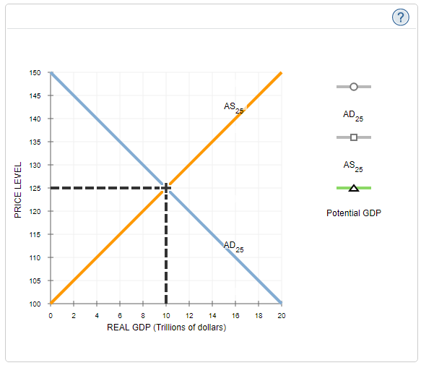

On the previous graph, shift the AD curve to illustrate the position of aggregate demand if actual inflation is higher than expected. Read the resulting price level and enter the inflation rate into a corresponding cell in the “Inflation Rate” column in the following table.
On the previous graph, shift the AD curve to illustrate the position of aggregate demand if actual inflation is lower than expected. Read the resulting value price level and enter the inflation rate into a corresponding cell the “Inflation Rate” column in the following table.
Unemployment Rate | Inflation Rate
(Percent) | (Percent)
4 | _____
8 | 25
16 | _____
On the following graph, use the purple curve (diamond symbols) to plot the short-run Phillips curve using the three unemployment and inflation rates from the previous table. Then use the green line (triangle symbols) to draw the long-run Phillips curve for this economy.

At the expected price level of 125, the natural rate of unemployment for this economy is ______ percent.

4. Monetary policy and the Phillips curve
The following graph shows the current short-run Phillips curve for a hypothetical economy; the point on the graph shows the initial unemployment rate and inflation rate. Assume that the economy is currently in long-run equilibrium.
Suppose the central bank of the hypothetical economy decides to increase the money supply.
On the following graph, shift the short-run Phillips curve or drag the blue point along the curve, or do both, to show the short-run effects of this policy.
Hint: You may assume that the central bank's move was unanticipated.

In the short run, an unexpected increase in the money supply results in ________ in the inflation rate and ________ in the unemployment rate.

On the following graph, shift the short-run Phillips curve or drag the blue point along the curve, or do both, to show the long-run effects of the increase in the money supply.

In the long run, the increase in the money supply results in ________ in the inflation rate and ________ in the unemployment rate (relative to the economy's initial equilibrium).

5. The effects of monetary policy with perfect inflation forecasting
Suppose that workers and firms perfectly forecast inflation, so that the real wage remains unchanged as the price level rises over time. Prices and wages rise at the same rate, which implies that the real wage stays constant.
The following graph shows the aggregate demand curve (AD) in an economy in long-run equilibrium. Assume the natural rate of unemployment is 6%, and potential output is $40 trillion.
Use the orange points (square symbol) to draw the aggregate supply curve in this case, and use the black point (plus symbol) to mark the equilibrium price level and real GDP.

On the following graph, use the purple points (diamond symbol) to draw the short-run Phillips curve for this economy when inflation is perfectly forecasted.

Now suppose the Federal Reserve decreases the money supply. Assume that an increase in the equilibrium price level translates into a higher level of inflation, and a decrease in the price level translates into a lower level of inflation. The effect of the Fed's policy is ________ in the inflation rate, ________ in the unemployment rate, and _________ in real GDP.

The school of economic thought most closely associated with this analysis is _________.

6. Expectations and the modern view of the Phillips curve
The following graph shows the short-run Phillips curve within the expectations framework.
On the graph, place the grey point (star symbol) to illustrate a situation in which people accurately anticipate the inflation rate.

When people accurately anticipate the inflation rate, the natural rate of unemployment is _____.

On the previous graph, place the black point (plus symbol) to illustrate a situation in which people overestimate inflation by 3%.
When people overestimate inflation, the resulting unemployment rate is _______ the natural rate.

True or False: The modern view of the Phillips curve indicates that to keep the unemployment rate low, policymakers should rapidly increase inflation rates.
True
False

7. Two types of economic growth
The following graph shows the aggregate demand curve (AD) and the short-run aggregate supply curve (SRAS) for a hypothetical economy that produces capital goods and consumer goods. Potential output is $6 billion.
Suppose the government pursues an expansionary fiscal policy.
On the graph, place the long-run aggregate supply curve (LRAS) in the appropriate position. Then, adjust the appropriate curve or curves to show the effect of the government policy.

According to the AD-AS model shown on this graph, the government policy _________ the real GDP.

Indicate how this situation would be represented in the production possibilities curve (PPC) framework.

The economy moves from an efficient level of production (on the PPC) to an inefficient level of production (inside the PPC).
The PPC shifts to the left.
The economy moves from an inefficient level of production (inside the PPC) to an efficient level of production (on the PPC).
The PPC shifts to the right.

Now, suppose the economy is operating at potential output of $6 billion. Recognizing that some of its regulatory policies are inefficient, the government revises the regulations for certain industries, decreasing costs of production. The long-run aggregate supply ( LRAS1 ) shifts to the right ( LRAS2 ). The aggregate demand curve ( AD1 ) also shifts to the right ( AD2 ). Suppose that the shift in the AD curve is the same amount as the shift in the LRAS curve.

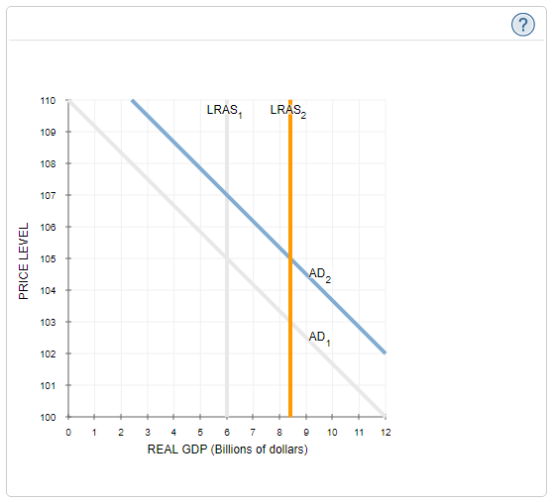
According to the graph, real GDP ________ and the price level _________.

Indicate how this outcome would be represented in the production possibilities curve (PPC) framework.

The PPC shifts to the left.
The PPC shifts to the right.
The economy moves from an efficient level of production (on the PPC) to an inefficient level of production (inside the PPC).
The economy moves from an inefficient level (inside the PPC) of production to an efficient level of production (on the PPC).

8. Factors that affect the trade-off between inflation and unemployment
Which of the following are arguments against the government taking action to decrease unemployment rather than inflation? Check all that apply.

Inflation is generally more costly to society than unemployment.
The short-run Phillips curve is relatively steep.
The economy's self-correcting mechanism works slowly.
Expectations about inflation change slowly.

